Three Things About Lucy Willow

There were three things that marked out Lucy Willow as different from other children. The first was that she lived on a train.
The second, just as important, was that she had a snail called Ernest as a pet.

And the third, the most important of all, was that she had green fingers. That means that she had a gift for growing things, though at the time this story begins she didn’t know it.
The Willow family hadn’t always lived on a train. When Lucy was younger they had lived in London, on the seventeenth floor of a high-rise block of flats. Dad didn’t like heights, they made him feel sick. Mum too felt a little queasy and just wanted a place of their own in the country.

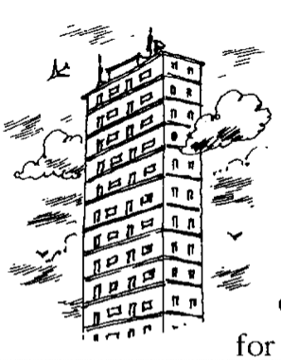
Mum dreamed of having a garden for vegetables and flowers. Up there in the clouds was no place for plants. Every month she would buy magazines full of pictures of country cottages, lovingly restored.
“Ah,” Mum would sigh. That’s my kind of house.”

If you had asked Dad what kind of house he dreamed of, without doubt he would have said an old railway station. For his passion was trains. His favourites were old steam trains. Once you got Mr Willow on to the subject of steam trains, there was no knowing where it would end.

But what about Lucy Willow? Where did she want to live? Why, that was easy. She didn’t mind as long as they were all happy. She did have responsibilities, though. She had her pet snail, Ernest, whom she kept in a shoebox and who went everywhere with her.
“Snails,” said Lucy, “like being on the ground near nature. They aren’t made for living on the seventeenth floor with the pigeons.”

And as it turned out, it was Dad’s love of trains that would hold the answer to all their problems.
(Extract from Lucy Willow by Sally Gardner)

