The Bolds in Trouble

Have you ever had something go wrong? You were expecting one thing and then something happened and you ended up getting something else completely different? Well I have, and it can be most upsetting. My mother once made a chocolate cake for tea. I took a bite and spat it out. It tasted horrible!

“Don’t be so silly,” said my mother, rather crossly. “It’s a lovely cake. Eat it!” But I couldn’t bring myself to. So then she tasted it herself and she couldn’t eat it either. “Something has gone wrong,” she said, pulling a face and gulping down some water to take the awful taste away. Then she looked in the cupboard where she kept the ingredients. Do you know what she had done? The cocoa powder was in a jar next to the gravy granules and she’d mistakenly picked up the wrong jar. She’d made a gravy cake!
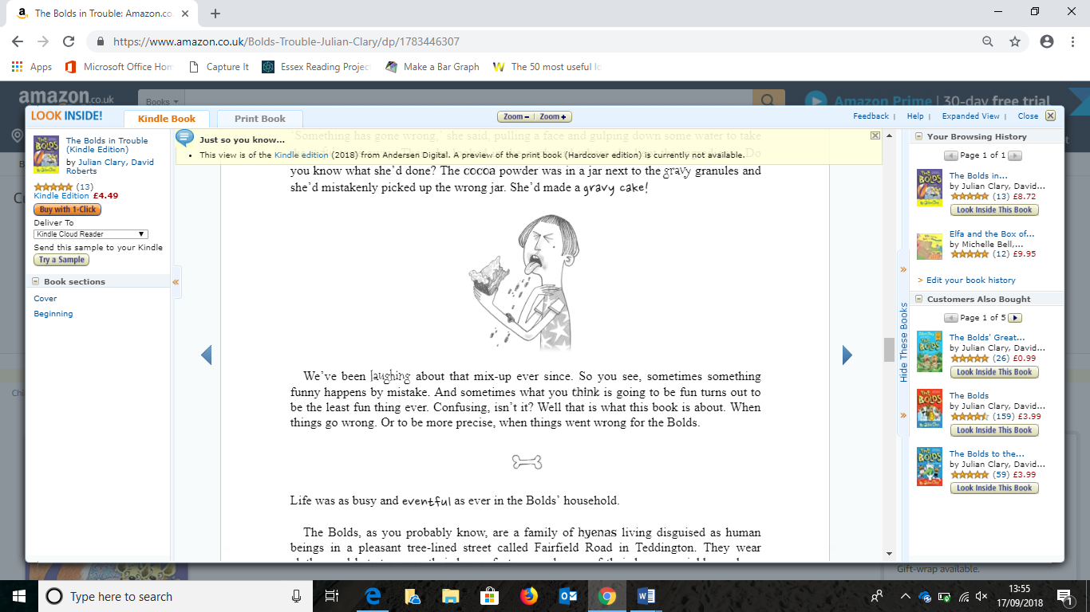

We’ve been laughing about that mix-up ever since. So you see, sometimes something funny happens by mistake. And sometimes what you think is going to be fun turns out to be the least fun thing ever. Confusing, isn’t it? Well that is what this book is about. When things go wrong. Or to be more precise, when things went wrong for the Bolds.

