The Penguin Parade
By Caroline Juskus
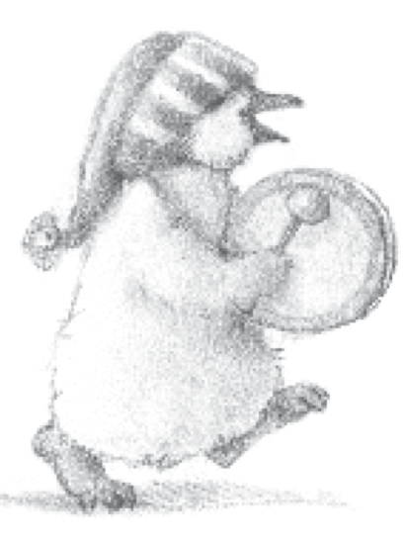

Pip the little penguin hopped up and down. He was bursting with excitement. In two days’ time he and his sister, Toots, were going to march in the Penguin Parade.
“The youngest penguins march at the front,” explained Toots, “and if we march nicely, children bring us buckets of shiny, silvery, sparkly presents.”
“Ooh!” said Pip. “What sort of shiny, silvery, sparkly presents?”
“It’s a surprise,” said Mum.
“Do you know Toots?”
Toots giggled. “Of course I do. I’m older than you.”
That’s not fair,” said Pip. “Please tell me.”
Mum shook her head. “It’s tradition,” she said. “Every young penguin gets a shiny surprise for their first Penguin Parade.”
But Pip didn’t want a surprise. He wanted to know NOW!
“Go and practise your marching,” said Mum, tickling Pip under his chin. “You’ll need to keep up with the other penguins and lots of them are bigger than you.”
Pip swung his flippers and jiggled his head.
Toots followed him. “Try and move your feet like me,” she said.
Pip hopped in the air and shuffled his feet, but they tangled together and he toppled over into the crisp white snow.

