The Owl Who Was Afraid Of The Dark
By Jill Tomlinson
“I don’t want to be a night bird,” Plop told his mummy. “Dark is nasty.”

“You don’t know that,” she said. “You’d better find out about the dark before you make up your mind. Look, there’s a little boy down there. Go and ask him.”

So Plop, who was quite new at flying, took a deep breath and flew down.

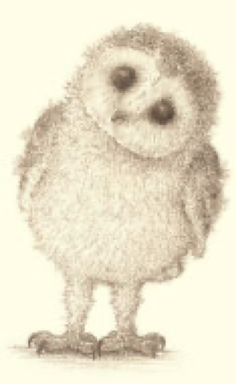

“Ooh!” cried the little boy as Plop landed with a bump.
“Hello!” said Plop. “I’ve come to find out about the dark.”
“Oh!” said the boy. “Dark is exciting, especially tonight. We’re going to have fireworks!”
“Does it have to be dark?” asked Plop.
“Of course!” replied the boy. “You can’t see the fireworks unless it’s dark. Look out for them later!”

“Well?” said Mrs Barn Owl when Plop arrived back at the nest.
“The little boy said dark is exciting,” said Plop. “I still do not like it AT ALL! But I will watch the fireworks if you will sit by me.”
“We will sit by you,” said his mummy and daddy.

So that is what they did.

