Frozen Kingdoms

Name


66.5° S
23.5° N
23.5° S
0°
These activities are for you to do at home. You can do all of them or choose the ones that you find most interesting.

Activities
- 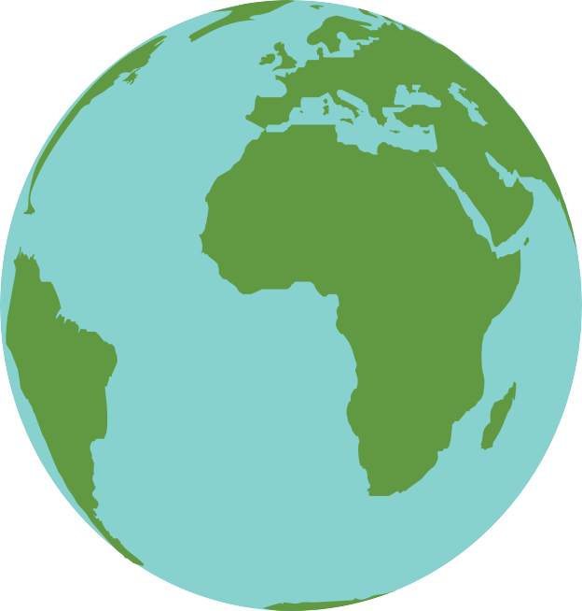Use the internet and other source materials to label the diagram of the Earth.
66.5° N
66.5° N Arctic Circle
23.5° N Tropic of Cancer
0°
23.5° S Tropic of Capricorn
66.5° S Antarctic Circle

Useful words
- equator • Prime Meridian • lines of latitude • lines of longitude

- This map shows world climate zones. Use the internet to research the characteristics of each and add a description of each to the key.
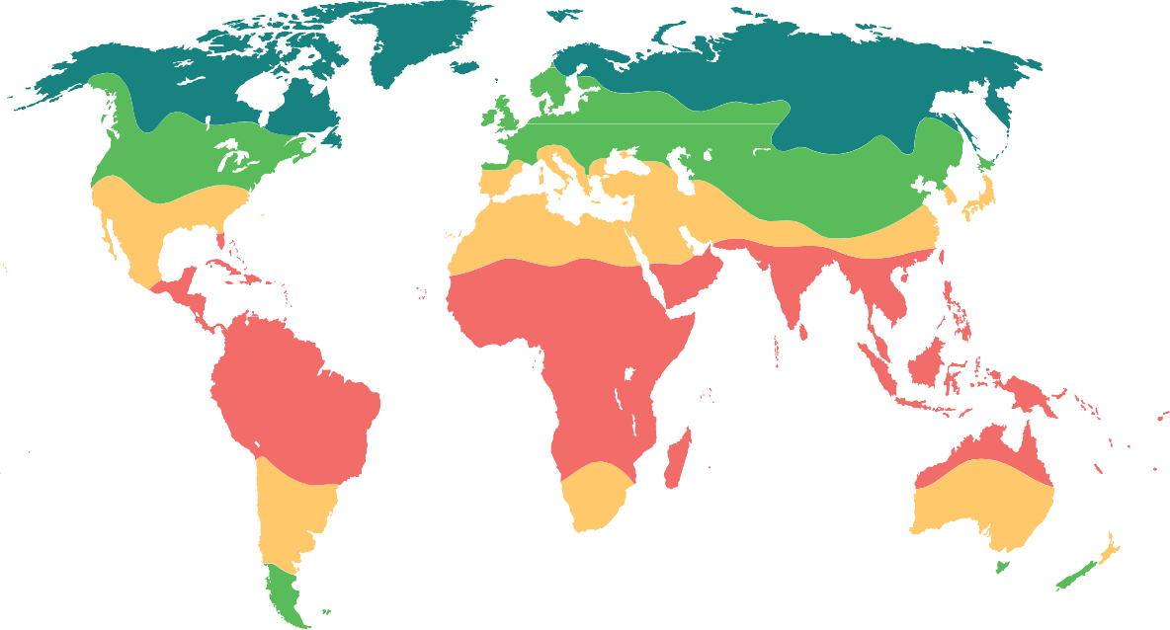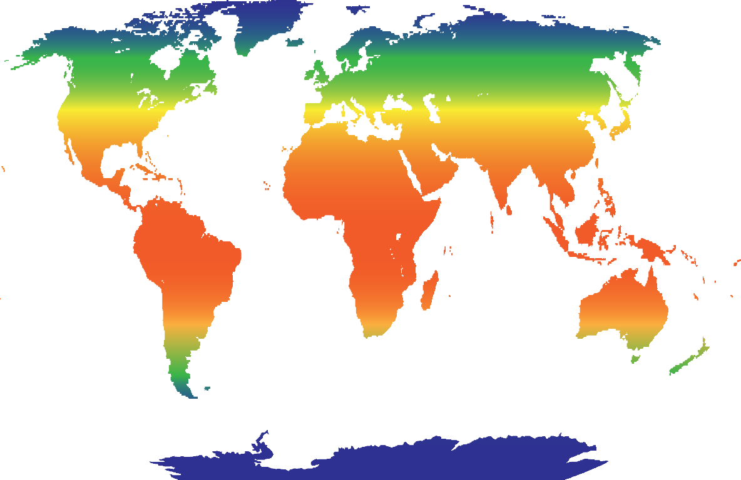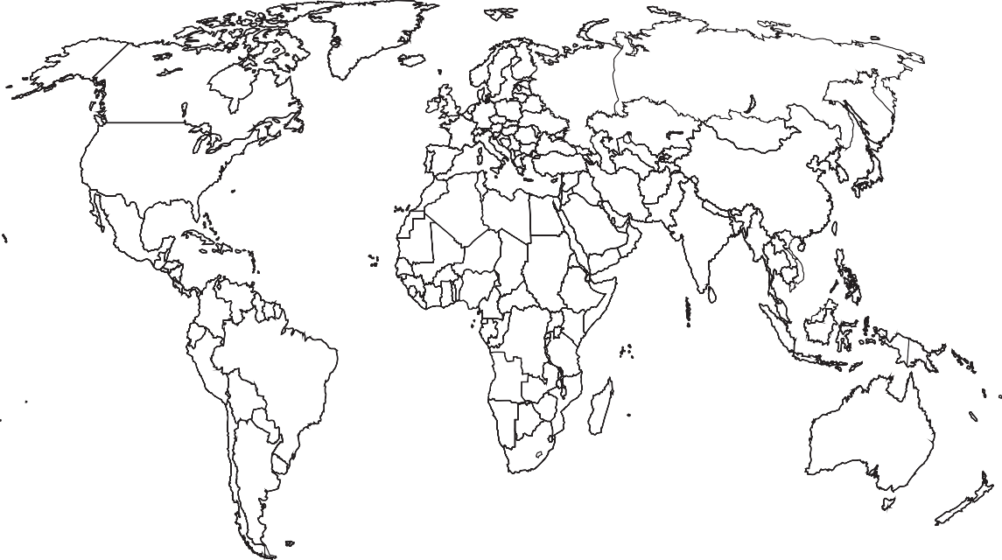
Arctic Circle
Tropic of
Cancer
Equator
Tropic of
Capricorn
Antarctic
Circle

polar zone

temperate zone

desert zone

tropical zone

equatorial zone

- Polar landscapes have many interesting natural features, including icebergs, glaciers, mountains, ice fields, tundra and boreal forests. Use the table to record a definition and description of each feature.
Image from: Wikimedia Commons/Public domain

Landscape feature | Definition | Description
Iceberg

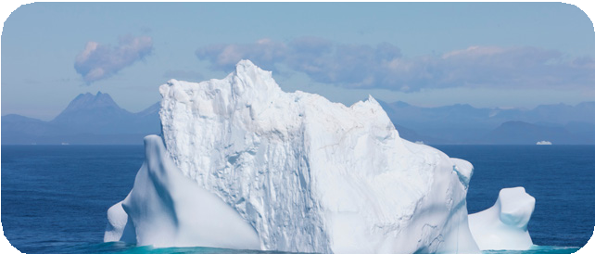
Glacier

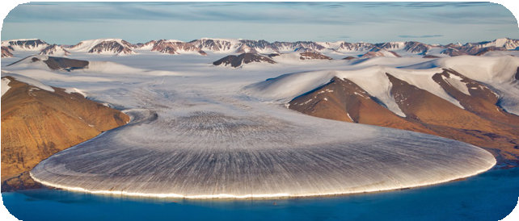
Mountain

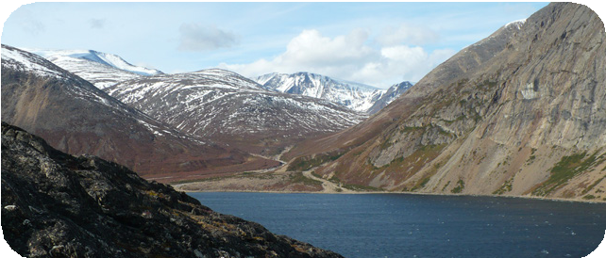
Ice field

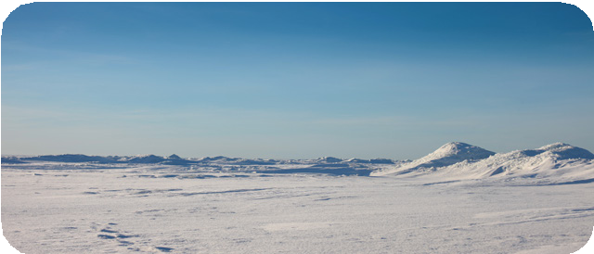
Tundra

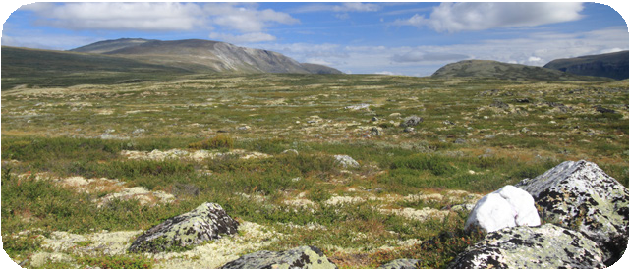
Boreal forest

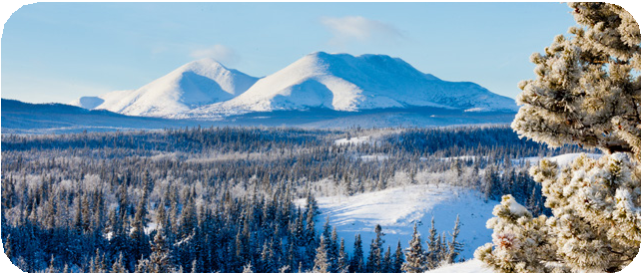

4a.

4b.
The Arctic is rich in natural resources, including oil, gas, wood, freshwater and hydropower. Use the mind map to write a short description of each.

freshwater
hydropower
Natural resources
oil
wood
gas

Which of these natural resources are used, and which are largely untapped?

5. Many people are concerned about the impact of climate change on the polar regions. Gather evidence to find the answers to the questions and give a personal view about climate change.
What is global warming?

What is climate change?

What are four causes of global warming?

1.

2.

3.

4. What is the impact of climate change on the planet?

What is the impact of climate change on wildlife?

What are your thoughts and feelings about climate change?

6a. Polar animals include polar bears, emperor penguins, Siberian salamanders, Greenland sharks, emerald rockcod, walrus and Arctic terns. Compare two of these species, recording where they are found, their habitats and what they eat.

Name of animal | Location found | Habitat | Diet

6b. Draw a detailed diagram of the two species that you compared. Add labels to identify their key features and adaptations.

7a. Throughout time, there have been many explorations of the polar regions.
Use the internet and other source materials to find out about polar explorers and their discoveries. Create a timeline to show significant polar explorations that took place between 1770 and 1920.

7b. Choose one polar explorer that you find inspiring. Find out as much as you can about them and write a short biography about their life, motives for exploration, achievements and discoveries.

Biography about

- This is the ‘Unsinkable’ RMS Titanic. Use online and other historical resources to find out what happened to RMS Titanic. Write an account to explain what
Image from: Wikimedia Commons/Public domain
happened, including how polar features were instrumental in its downfall. Use the useful words provided to help you write your report.
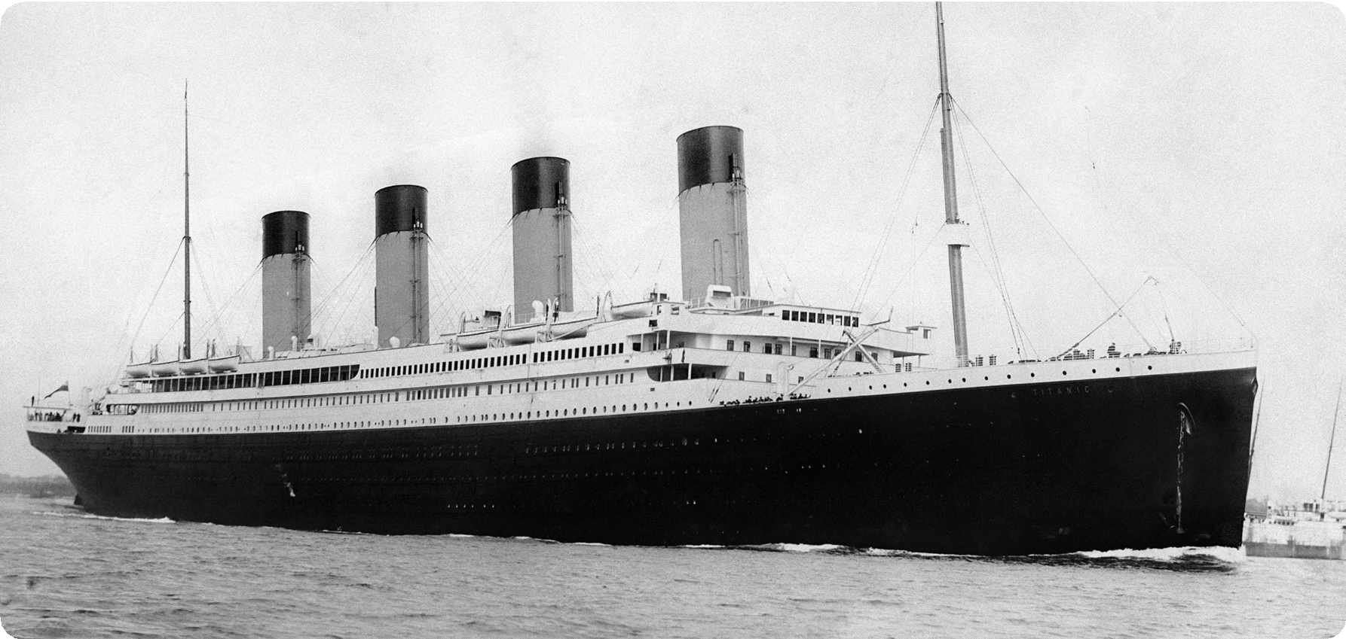

Useful words
- disaster
- ice
- iceberg
- lifeboats • maiden
- New York City • RMS Titanic • Southampton • voyage

- Finish your home learning by writing a summary of the topic, explaining what you have learned about the polar regions, including their locations, wildlife, resources, indigenous peoples and threats.

Useful websites
Britannica Kids – Antarctica Britannica Kids – Arctic Regions Met Office – Climate zones
National Geographic Kids – What is climate change? DKfindout! – Polar Exploration – Famous Polar Explorers Britannica Kids – Polar Exploration
National Geographic Kids – Titanic Facts

Good reads

Title | Author | ISBN
Arctic and Antarctic | DK | 9781405394628
Research on the Edge: Polar Regions | Louise Spilsbury | 9780750289900
Polar Climates | Cath Senker | 9781474738422
Ecographics: Climate Change | Izzi Howell | 9781445165714
Polar Explorers for Kids | Maxine Snowden | 9781556525001
Story of the Titanic | DK | 9781409383390

