Sow, Grow and Farm

Name


These activities are for you to do at home. You can do all of them or choose the ones that you find most interesting.

Activities
- Learn about agriculture and farming in the UK and worldwide using a range of sources. Create a mind map to organise and record your findings under headings of your choice, then use your mind map to write a non-chronological report. Include a title, an opening paragraph, subheadings, detailed and interesting facts, precise topic vocabulary and images with captions.

Agriculture and farming

- Research the following terms and write a definition for each to create a project glossary. Add other topic-related words to your glossary as you complete the other home learning activities.

allotment

arable farming

commercial farming

floriculture

market garden

mixed farming

organic farming

pastoral farming

- Use the BBC Food and Good Food websites to find out which foods are in season in the UK throughout the year. Complete the table, listing seasonal foods by month. Afterwards, use the BBC Good Food website to find a recipe for a seasonal meal. Write a shopping list, then prepare the meal with an adult.

January | February | March
April | May | June
July | August  apple, apricot, aubergine, beetroot, blackberry, crab, French beans, pepper, radish, sea bass, sweetcorn, tomato and venison | September
October | November | December

- This still life painting, called Basket of Fruit, is by the artist Michelangelo Merisi da Caravaggio. A still life is a painting or drawing of an arrangement of objects, such as flowers, fruits and vegetables. Collect and arrange a selection of seasonal produce, then create a still life drawing or painting of your arrangement. Think about including tints and shades of colour in your piece. Remember to give your completed artwork a title.
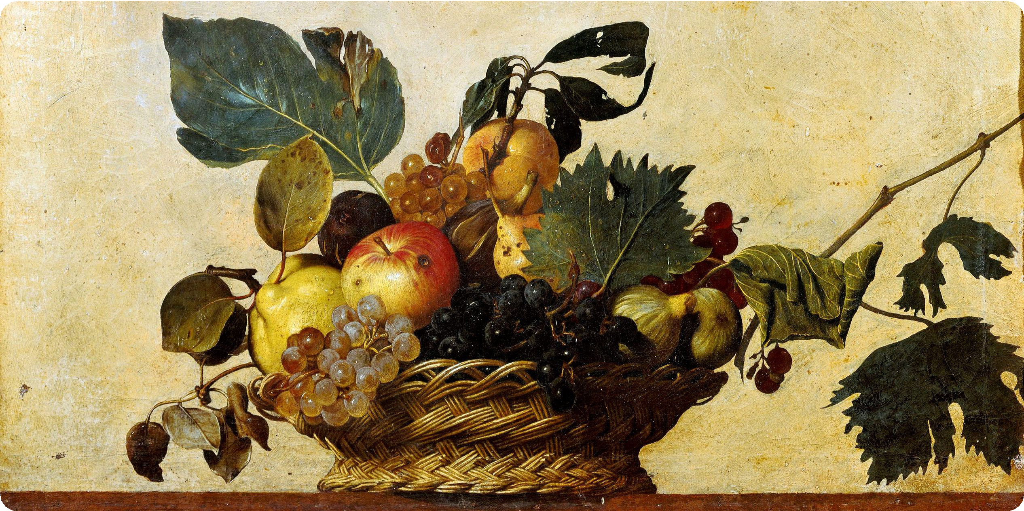

- Gardens and allotments are habitats for many living things. These living things rely on each other as a food source. Recap on food chains and webs using various sources, then draw a food chain or web for a garden or allotment habitat.
Image from: Wikimedia Commons/Public domain

- Learn about a flowering plant’s life cycle and how they reproduce, including which plant parts are involved in reproduction, using information books and the internet. Record your findings as a scientific report using labelled diagrams and specific examples. Share your report with a family member.

- 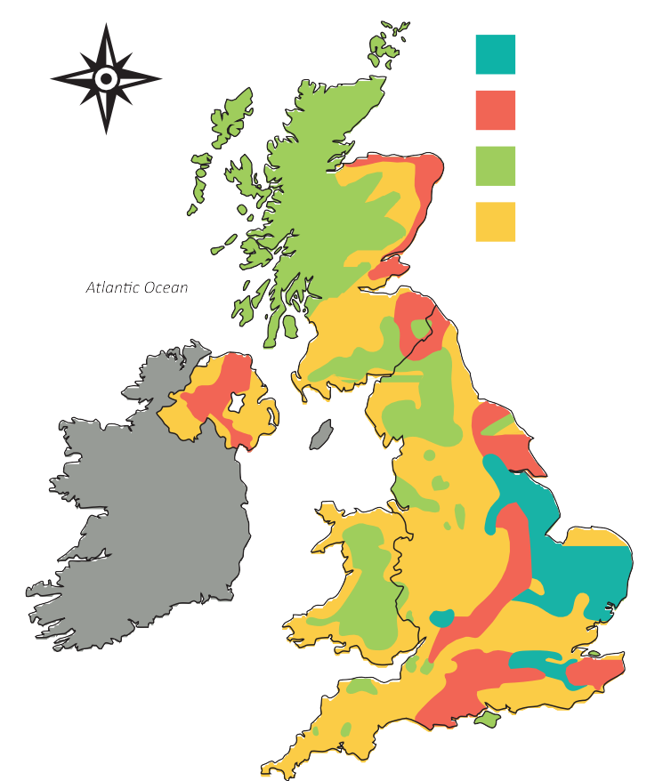Look at the map and key. Write a paragraph to explain what the map tells you about farming in the United Kingdom, then answer the questions.
north
south
east
west
KKeeyy
aarrabablele mimixxeded
ppaassttoorralal (sheep(sheep))

ppaassttoorralal (d(daiairry)y)
orth
n north
Key
west
arable
west
est
east
east
south
south
mixed

pastoral (sheep)
S c oo tt l aa nn d
pastoral (dairy)
North Sea
Northern Ireland
Irish Sea
E nn gg l a n d
I r e l a n d
Wales
Wales
English Channel

Where does arable farming take place in the UK? In which country and what areas?

The map shows which types of pastoral farming?

Use Google Earth to look at the areas where pastoral, arable and mixed farming occur. What do you notice about the geographical features in the areas where each type of farming takes place?

Use your research skills to answer these questions.
What products do some of the areas of arable and pastoral farming produce?

arable pastoral
What tasks do UK pastoral and arable farmers carry out to take care of their animals and crops and produce products to sell? In what conditions do they work? How does this compare with a different type of farming elsewhere in the world?

Pastoral farming | Arable farming

- Choose a type of farming, such as floriculture, arable farming or dairy farming. Imagine that you are a farmer for this farming type. Research, then write a series of diary entries about your work. Include dates, events in chronological order, interesting factual details, and feelings, reactions and opinions. Use personal pronouns, such as I and we.

- Use your research skills to find out about the Dig for Victory campaign from the Second World War. Find out why the government encouraged people to grow fruit and vegetables and record your findings. Find examples of posters made for the campaign, then create your own to promote the growing of produce, giving reasons and benefits.

- Finish your home learning by writing a summary of the topic, explaining what you have learned about farming in the UK and worldwide, seasonality, food chains and webs, plant life cycles and plant reproduction.

Useful websites
Britannica Kids – Agriculture
The School Run – Food and farmland for KS1 and KS2 children Cambridge Learner’s Dictionary – Definitions and meanings BBC Good Food – Seasonal calendar
DKfindout! – All About Plants for Kids – Plant Facts DKfindout! – Food Chains For Kids – Facts About Food BBC Two – This Farming Life
New Scientist Jobs – A day in the life of a farmer
BBC News – Digging for Victory: Stories from wartime gardens The British Library – Dig for Victory

Good reads

Title | Author | ISBN
Source to resource: From Field to Plate | Michael Bright | 9780750292030
Agriculture and Land Use – Environmental Issues | Emilie Dufresne | 9781786375995
The Wonderful World of Food | Wiley Blevins | 9781474746571
Plant Parts: Flowers | Melanie Waldron | 9781406274776
Earth by Numbers: Plant Structures | Nancy Dickmann | 9781474765428
Food Chains: Who Eats What? | Sam Hutchinson | 9781911509929

