Misty Mountain, Winding River

Name


These activities are for you to do at home with an adult. You can do all of them or choose the ones that you find most interesting.

Activities
- Use a range of sources to learn about rivers. Record information under each of the headings on the mind map below.

How rivers form Three stages of a river

Rivers

How rivers change the landscape How people use rivers

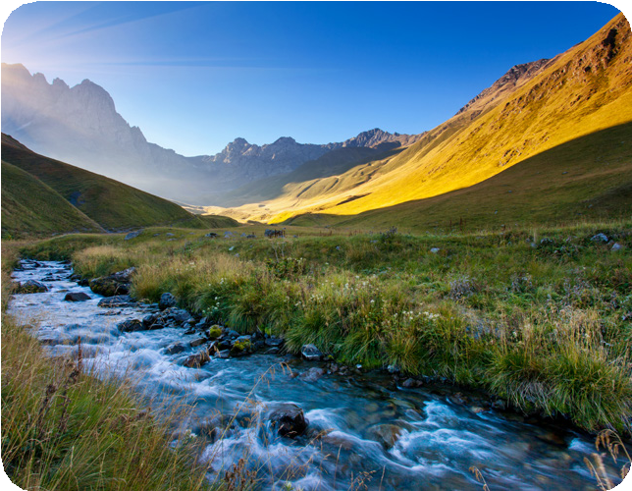
- Use a range of sources to find out what features are found at the upper, middle and lower courses of a river. Record your findings below.

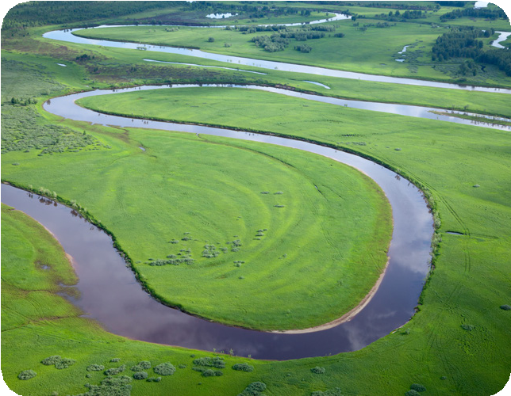
upper course

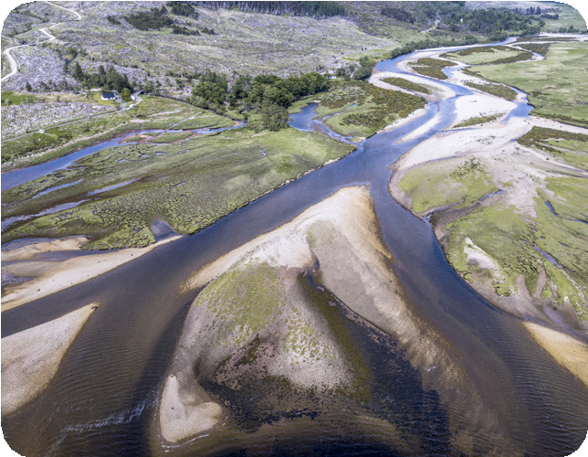
middle course

lower course

- Use an atlas, map or online tool, such as Google Earth, to find a range of rivers worldwide, including rivers in the United Kingdom. Trace each river’s journey by locating the source and following the river’s course to its mouth.
- Choose one worldwide river to learn about using information books and the internet. Write a leaflet about your chosen river to record your findings. Include a title, headings, pictures and facts. Once complete, share your work with a family member.
- Find out what defines a mountain, how they form, different types of mountain and mountain habitats. Choose a topic relating to mountains and create an information poster to record your findings.

6a. Find 10 worldwide mountains, including mountains in the United Kingdom. Mark and label the mountains on the world map.
Key
Mountain

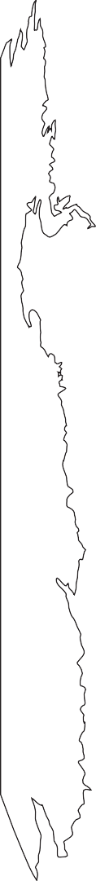
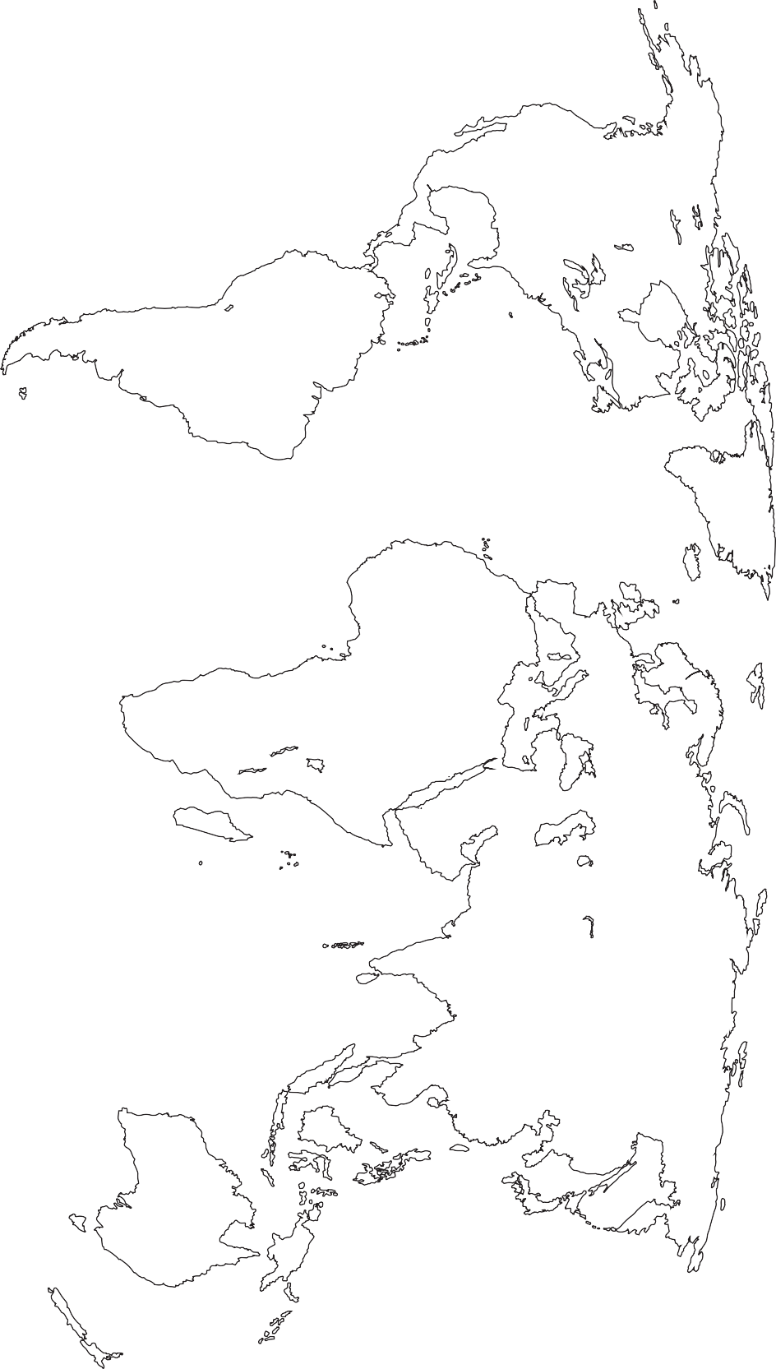

6b. Choose three mountains from your world map. Use your research skills to complete the table about your chosen mountains.

Mountain name
Location
Features
Fascinating facts

- Enjoy a riverside or hilltop walk with your family. Before your outing, explore the area using an Ordnance Survey map to examine the contour lines, grid references and other features. When you arrive home, write a diary entry about the day. Include the date, events in chronological order, facts and your thoughts and feelings.

Diary entry

- Many people use rivers and mountains for leisure and sporting activities. Answer the questions and complete the tasks below, using a range of sources to help.

What leisure and sporting activities do people do on rivers?

Choose three of these activities and complete the table.

Activity | Equipment needed

Hiking, rock climbing and fell running are activities that people carry out on hills, rocky outcrops and mountains. Write a definition for each activity.

Hiking

Rock climbing

Fell running

What equipment might people need to enjoy these activities safely?

Activity | Equipment needed
Hiking
Rock climbing
Fell running

- Finish your home learning by writing a summary of the topic, explaining what you have learned about rivers and mountains.

Useful websites
BBC Bitesize – Rivers DKfindout! – What Is A River? BBC Bitesize – River stages
BBC iPlayer – Earth’s Great Rivers
Britannica Kids – Mountains – Homework Help
DKfindout! – How Are Mountains Formed? – Mountain Facts BBC One – Planet Earth – Mountains
BBC Bitesize – Grid references, scale and measuring

Good reads

Title | Author | ISBN
Rivers and Mountains – Physical and Human Geography | Joanna Brundle | 9781786371560
Discover & Learn: Rivers The Study Book – KS2 Geography | CGP | 9781782949749
Great Rivers: Rivers of the World | Catherine Brereton | 9781474754057
Horrible Geography: Raging Rivers | Anita Ganeri | 9781407196237
Geographics: Mountains | Izzi Howell | 9781445155241
Tough Guides: How to Survive on a Mountain | Louise Spilsby | 9781526309587

