Rocks, Relics and Rumbles

Name


These activities are for you to do at home. You can do all of them or choose the ones that you find most interesting.

Activities
- Create a model of the layers of the Earth using a range of materials. Label each layer and write a short description about each layer’s features. Sketch your idea for a model below.

- There are three main rock types. These are sedimentary, igneous and metamorphic. Briefly describe how each type is formed, their properties and at least two examples of each type.

sedimentary

igneous

metamorphic

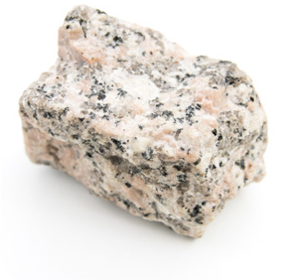
- Use a range of sources to complete the table about the three different rocks shown.

Rock | 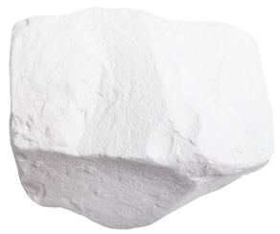  chalk | granite | 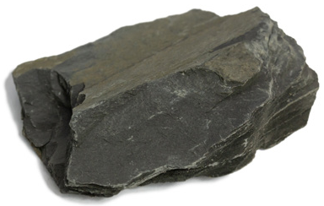  slate
Type
(sedimentary, igneous or metamorphic)
Appearance
Properties
Uses

- Investigate the soil in your garden and local area. Dig a hole 10cm deep and scoop up a handful of soil from the bottom. Remove large stones and roots, sprinkle a little water on it and try to work the soil into a ball. Use the soil key to identify the soil type and record your results. Be careful of broken glass and sharp metal and wash your hands afterwards.


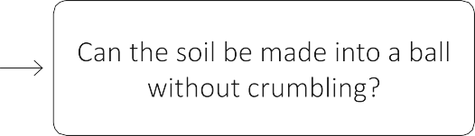
Squash the ball to try to flatten it. Does the ball break apart when squashed?

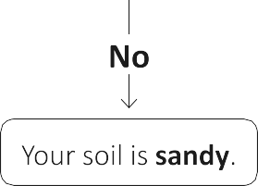

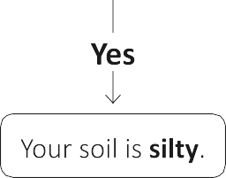
- Make an information poster about Mary Anning, the famous fossil collector. Include images and interesting facts. Share your poster with a family member once it is complete.

- Write a poem on the theme of volcanoes. You might like to write about an eruption, a specific volcano that you have learned about or the damage caused after a volcanic eruption. Try to include expanded noun phrases in your poem. For example, scorching hot, exploding lava or jet-black clouds.

- Find the latitude and longitude coordinates for 10 places around the world. Record the places and coordinates in the table.

 | Place name | Coordinates
Somewhere in Africa
Somewhere in Antarctica
Somewhere in Asia
Somewhere in Australia
Somewhere in Europe
Somewhere in North America
Somewhere in South America
Your favourite holiday destination
Your home town
Somewhere you really want to go

- Imagine that you have just experienced an earthquake. Write a short story about what happened. Use topic vocabulary to describe the strength of the earthquake, such as tremor, epicentre, magnitude and seismic wave.

- Finish your home learning by writing a summary of the topic, explaining what you have learned about the layers of the Earth, volcanoes and earthquakes.

Useful websites
DKfindout! – Earth’s Layers – Inside the Earth Britannica Kids – Plate tectonics
DKfindout! – Rocks and Minerals
National Geographic Kids – Mary Anning Facts! DKfindout! – How Tectonic Plates Move
BBC Bitesize – Latitude and Longitude DKfindout! – Earthquake Facts

Good reads

Title | Author | ISBN
Earth (DKfindout!) | DK | 9780241285107
A Finders' Guide to Rocks, Fossils and Soils (Collins Big Cat) | Alison Milford | 9780008208776
Everything Volcanoes and Earthquakes | National Geographic Kids | 9780008267810
Volcanoes and Earthquakes Activity Book (KS2 Discover and Learn) | CGP | 9781782949732
Mary Anning: The Girl Who Cracked Open The World | Debora Pearson | 9780435164546

