Ancient Civilisations

Name


These activities are for you to do at home with an adult. You can do all of them or choose the ones that you find most interesting.

Activities
- Use your research skills to find out what an ancient civilisation is. Write a simple definition, then list the characteristics of a civilisation. List the names of some ancient civilisations found from your research.

An ancient civilisation is

Characteristics Ancient civilisations

- Use information books and the internet to find out about archaeology, archaeologists, archaeological sites and artefacts. Create an information poster or non-chronological report to record your findings. Include images if you can. Once complete, share it with a family member.

- Three of the world’s first civilisations include ancient Sumer, ancient Egypt and the Indus Valley civilisation. Imagine that you are an archaeologist examining these three artefacts. Complete the table to record your observations and ideas.
Image from: Metmuseum/Public domain

Civilisation | Ancient Sumer | Ancient Egypt | Indus Valley
Artefact | 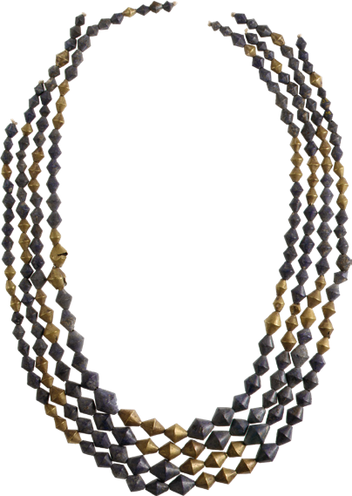 | 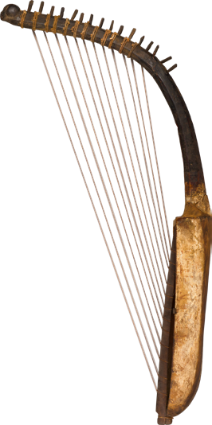 | 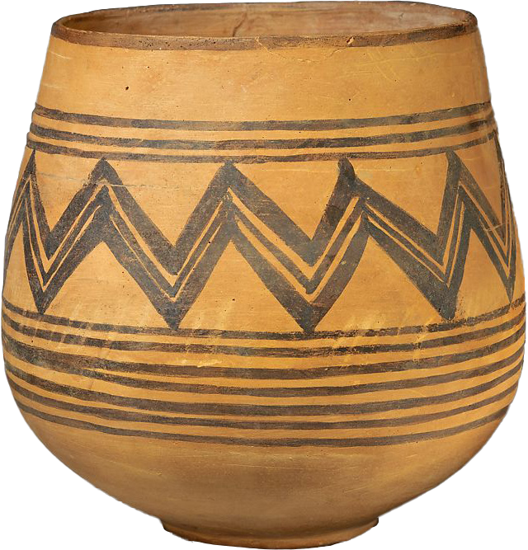
Artefact type
Materials
Possible uses
Description

Afterwards, you might enjoy searching the online collections of The British Museum or The Met Museum to view other artefacts from ancient Sumer, ancient Egypt or the Indus Valley.

- Use your existing knowledge and research skills to match each of the civilisations to the correct information.


ancient Sumer c4500–c1900 BC
This civilisation lived in cities, towns, villages, and countryside estates near the banks of the Nile. This location provided freshwater, fertile farmland and land suitable for building. The population of this civilisation lived in and around two busy capital cities called Thebes and Memphis. Their rulers were kings or queens named pharaohs. Famous pharaohs include King Narmer, King Hatshepsut, King Akhenaton and King Tutankhamun.

ancient Egypt c3100–30 BC
This civilisation built thousands of cities and settlements along the banks of the Indus River, which is in modern Pakistan. Two of the largest cities that archaeologists have discovered are called Harappa and Mohenjo-daro.
Archaeologists believe that they are the world’s first planned cities, with the earliest known sewerage and drainage systems.

Indus Valley c2500–c1700 BC
This was the world’s first civilisation. This civilisation settled in an area of the Fertile Crescent in Mesopotamia. They settled near the banks of the Tigris and Euphrates rivers. Here, the soil was full of nutrients and perfect for growing crops. The people of this civilisation invented many things, including a brick mould, irrigation and the plough.

- What did the ancient Sumerians invent, and how did these inventions make work easier and improve everyday life? Use information books and the internet to answer this question. Record information on the mind map. Expand on the information in your mind map by writing a summary to answer the enquiry question.

Numbering system
A numbering system meant that the Sumerians could keep records of large quantities of goods and design huge buildings.

ancient Sumerian inventions

What did the ancient Sumerians invent, and how did these inventions make work easier and improve everyday life?

- Use information books or the internet to find out about pharaohs of ancient Egypt. Choose two pharaohs that you find interesting, draw a picture of them, record the dates of their reign and write a fascinating fact about each one.

Name:

Date of reign:

Fascinating fact:

Name:

Date of reign:

Fascinating fact:

- Read a book containing ancient Egyptian myths. Choose your favourite myth and retell the story to a family member. Afterwards, illustrate your favourite
scene from the story. Write a description beneath your picture to explain what is happening.

- Archaeologists have recovered over 3500 seals from the Indus Valley civilisation. Use the images and your research skills to find the answers to the questions.
Image from: Metmuseum/Public domain

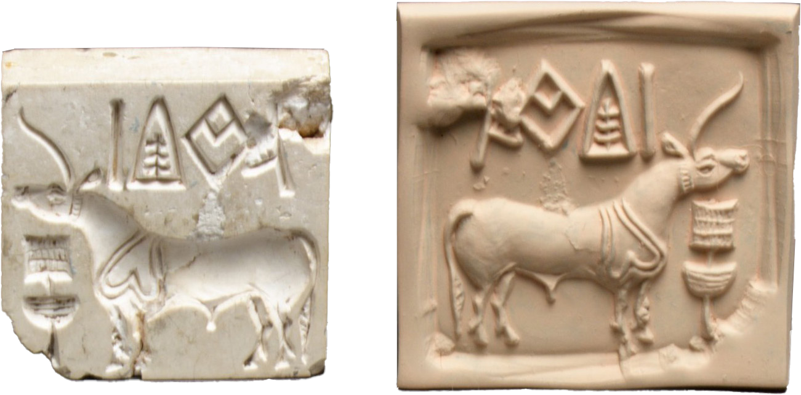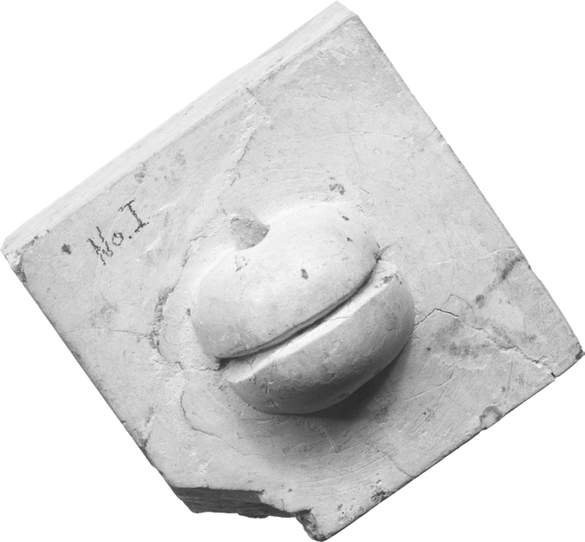

Front view of two seals Back view of a seal What are these seals?

What were they used for?

Why are they important artefacts today?

- Compare the ancient Sumerian, ancient Egyptian and the Indus Valley civilisations by finding out what life was like for the people who belonged to them, using
a range of sources. Complete the table to record your findings and make comparisons.

 | Ancient Sumer | Ancient Egypt | Indus Valley
Location
Achievements
Daily life
Other interesting information
End of the civilisation

- Finish your home learning by writing a summary of the topic, explaining what you have learned about ancient civilisations.

Useful websites
Britannica Kids – Archaeology – Homework Help Britannica Kids – Ancient civilisation – Homework Help BBC Teach – Introducing Ancient Sumer – History KS2 BBC Bitesize – Ancient Egypt – KS2 History
DKfindout! – Egyptian Pharaohs
BBC Bitesize – Indus Valley – KS2 History
BBC Bitesize – What was everyday life like in the Indus Valley?

Good reads

Title | Author | ISBN
Technology in the Ancient World: Sumer and Ancient Mesopotamia | Charlie Samuels | 9781445142630
Explore!: Ancient Sumer | Rachel Minay | 9781526300898
Discover & Learn: Ancient Egyptians The Study Book – KS2 History | CGP | 9781782949688
Ancient Egypt: Tales of Gods and Pharaohs | Marcia Williams | 9781406338324
Egyptian Myths | Eric Braun | 9781474752503
Facts and Artefacts: Indus Valley Civilisation | Tim Cooke | 9781445161938

