Emperors and Empires

Name


These activities are for you to do at home with an adult. You can do all of them or choose the ones that you find most interesting.

Activities
- Use a range of sources to create a timeline, showing the chronology of the Roman Empire from 753 BC to AD 476. Highlight the dates that show when the Romans were in Britain.

- Find out about the everyday lives of children in ancient Rome, using a selection of historical source materials. Write an imaginative diary entry, from the point of view of a Roman child, that includes correct historical information.

- Look at this illustration of a Roman soldier. Use your knowledge and a range of historical sources to label each part of his clothing and armour.
Image from: Getty Images/Heritage Images

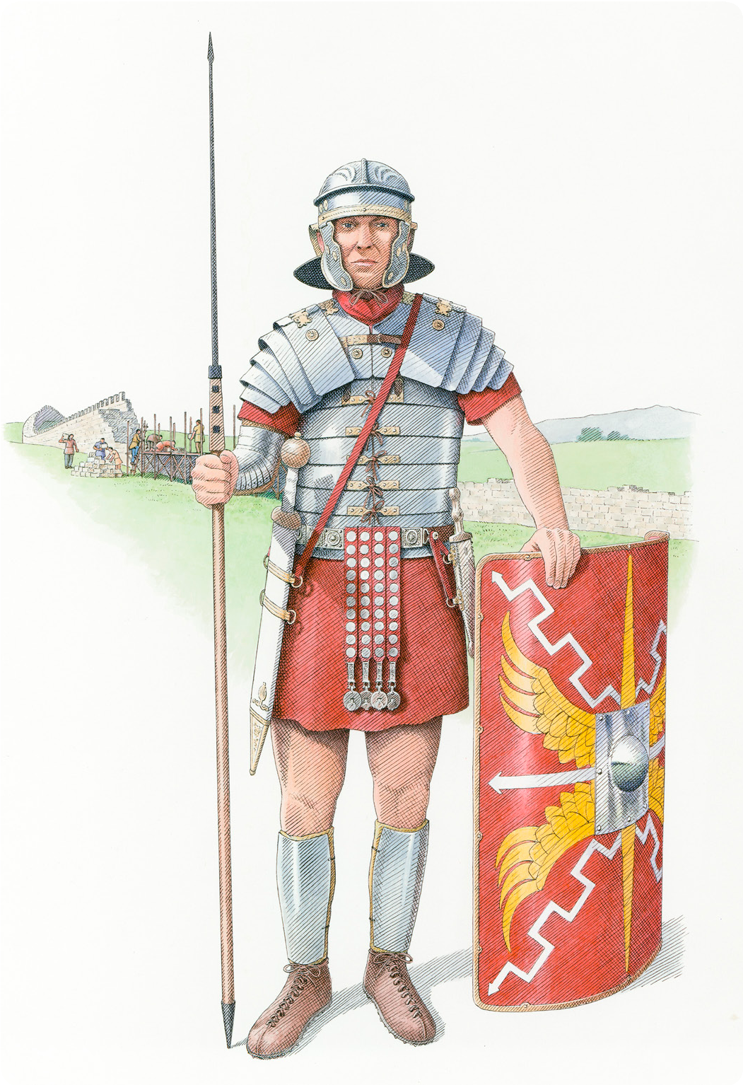

- Put these people into a diagram to show the hierarchy of ancient Rome.
  - emperor
  - slaves
  - plebeians and freed people
  - patricians
  - equites
Write a short paragraph to describe the different roles that these people played in Roman society.

- Use a range of historical source materials to find out how the Roman invasion transformed the lives of the Celtic Britons. Use the information gathered to write a short non-chronological report.

How the Romans changed Britain

- Visit the Roman Vindolanda Fort & Museum website to find out about artefacts and tablets found at Vindolanda, near Hadrian’s Wall. Explore the website
to gather information and organise your findings in a Vindolanda knowledge organiser.

- The Romans worshiped many different gods. Find out about these gods and write a short profile about each one.

Jupiter

Diana

Pluto

Mars

Juno

- By AD 410, Roman troops had left Britain and returned to Rome. Find out about the impact of the Roman withdrawal and write a short descriptive account, blog or presentation to explain what happened.

- Finish your home learning by writing a summary of the topic, explaining what you have learned about ancient Rome, the Roman Empire and the Roman invasion of Britain.

Useful websites
Roman Vindolanda Fort & Museum Roman Britain – BBC Bitesize DKfindout! – Romans
Day in the Life of a 10-year-old in Roman Britain – BBC Hands on History

Good reads

Title | Author | ISBN
What the Romans Did For Us (From Takeaways to Motorways) | Alison Hawes | 9781408112861
Romans on the Rampage | Jeremy Strong | 9780141357713
Rotten Romans (Horrible Histories) | Terry Deary | 9781407163840
Ancient Rome (Eyewitness) | DK | 9780241187753
See Inside Ancient Rome (An Usborne Flap Book) | Katie Daynes | 9780746070031
The Romans: Gods, Emperors and Dormice | Marcia Williams | 9781406354553

