Britain at War

Name


These activities are for you to do at home. You can do all of them or choose the ones that you find most interesting.

Activities
- Britain and its inhabitants have fought in or endured several significant conflicts throughout history. Use a range of sources to find out about the conflicts listed and Britain’s involvement. Record your findings in the table.

Conflict and dates | Countries or people involved | One major cause of the conflict | One major consequence of the conflict
Norman Conquest of England
Wars of the Roses

Conflict and dates | Countries or people involved | One major cause of the conflict | One major consequence of the conflict
English Civil War
Napoleonic Wars
Crimean War

Conflict and dates | Countries or people involved | One major cause of the conflict | One major consequence of the conflict
First World War
Second World War

- Discuss with a family member what the words ‘conflict’ and ‘war’ mean and look up their meaning in a dictionary. Then use a dictionary to write definitions for the terminology below.

alliance

expansionism

fascism

imperialism

invasion

militarism

nationalism

retaliation

- Use your existing knowledge and a range of sources to write a report about the First World War. Record your findings on the mind map and use the information to help you write your report. Include a title, an opening paragraph, a timeline of key events, subheadings, detailed facts, precise topic vocabulary and images with captions.
How the war ended and what happened next
First World War
Front line and home front
Key events
Warring nations
Causes

- Use a range of sources to look at images of First World War trenches. Find out about trench warfare and then answer the questions.

Why were trenches used during the First World War?

What did trench warfare involve?

What was life like for the soldiers in a First World War trench?

- Use your existing knowledge and a range of sources to write a report about the Second World War. Record your findings on the mind map and use the
information to help you write your report. Include a title, an opening paragraph, a timeline of key events, subheadings, detailed facts, precise topic vocabulary and images with captions.
How the war ended and the consequences of war
Second World War
Effects of the war on everyday life
Key events
Warring nations
Causes

- Use a range of sources to find out about the important events listed, which involved Britain during the Second World War. Record your findings in the table.

Event and dates | Key findings
Battle of Britain
Blitz
D-Day

- The Ministry of Information produced persuasive posters during both the First and Second World Wars to affect people’s opinions and actions. Use online sources to learn more about wartime posters and to find examples. Then, answer the questions and complete the table.

What was the purpose of persuasive posters in the First and Second World Wars?

Propaganda was a feature of some wartime posters. What is the definition of the word propaganda?

In what different ways did posters encourage British people to get involved in the war effort during the First World War?

In what different ways did posters encourage British people to get involved in the war effort during the Second World War?

Poster | Who was it aimed at? | What was it meant to achieve? | How effective do you think it was and why?
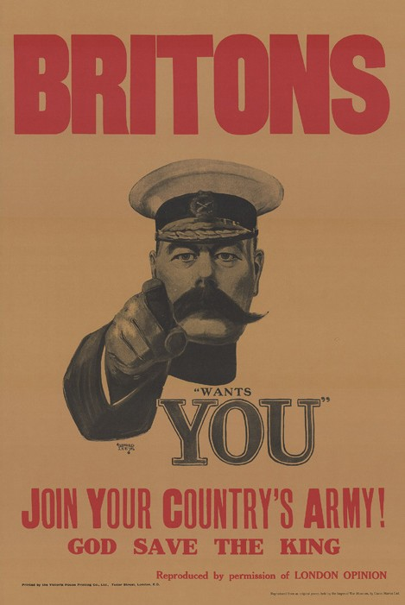
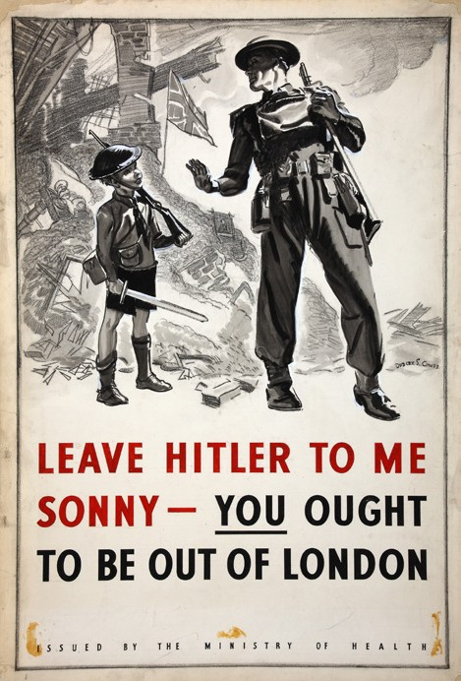
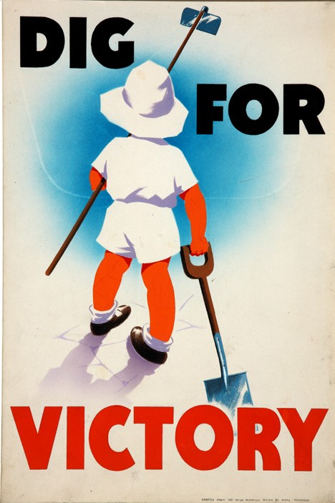
Image from: Wikimedia Commons/Public domain
Image from: Getty Images/IWM/Getty Images

- Experts developed different weapons, innovations and technology during the First and Second World Wars to help each side defeat their enemies. Find out about one new weapon and one new innovation or technological advance that you find interesting and complete the table.

 | Weapon | Innovation or technological advance
Name and date developed
Printed image or sketch
Description
Use

- Read a historical narrative, poems or age-appropriate real-life stories about either the First or Second World War. There are many suitable and award-winning titles available. Examples include: Letters from the Lighthouse by Emma Carroll, War Horse, Private Peaceful or Only Remembered by Michael Morpurgo, The Skylark’s War by Hilary McKay, Poems from the Second World War by Gaby Morgan, Archie’s War by Marcia Williams, Anne Frank – The Diary of a Young Girl (Abridged for young readers) by Mirjam Pressler or Voices from the Second World War by First News.

- Finish your home learning by writing a summary of the topic, explaining what you have learned about Britain’s involvement in conflicts throughout history and the First and Second World Wars.

Useful websites
Britannica Kids – Norman Conquest Britannica Kids – Wars of the Roses Britannica Kids – English Civil War
DKfindout! – Facts About The Napoleonic Wars Britannica Kids – Crimean War
BBC Bitesize – World War One – KS2 History BBC Teach – World War Two
Imperial War Museums – Living in the Trenches Britannica Kids – Battle of Britain
Britannica Kids – Blitz Britannica Kids – D-Day
BBC Teach – How propaganda was used during World War Two – History KS2 Imperial War Museums – Second World War Posters

Good reads

Title | Author | ISBN
Usborne History of Britain: The First World War | Henry Brook | 9781409570240
Weapons of World War I | Matt Doeden | 9781474748384
Poppy Field | Michael Morpurgo | 9781407181424
DK Eyewitness: World War II | DK | 9781409343677
Weapons of World War II | Matt Doeden | 9781474748377
When we were Warriors | Emma Carroll | 9780571350407

