Groundbreaking Greeks

Name


These activities are for you to do at home. You can do all of them or choose the ones that you find most interesting.

Activities
- Use your existing knowledge and research skills to match each period of Greek history to the correct information facts about the period. One has been done for you.

Neolithic
c6000–c3000 BC
This civilisation lasted for the duration of the Greek Bronze Age. The people lived on the island of Crete and were the first advanced civilisation in Europe. They were excellent farmers, skilled potters and good sailors.
The people were wealthy and lived in communities ruled by kings.
Minoan civilisation c3000–c1100 BC
People started to grow crops, rear livestock, produce oil from olives and make wine from grapes. They sculpted pottery and created tools from stone, wood and copper. They lived in circular huts or houses with rectangular rooms.

Mycenaean civilisation c1600–c1100 BC
During this time, many cities were destroyed or abandoned. Historians are unsure whether this was due to invasion, accident or natural disasters. Written language and art disappeared. However, ironworking skills reached Greece from the east at this time, so the period is also known as the Early Iron Age.

Dark Age
c1100–c800 BC
This civilisation was named after a city on the Greek mainland. Its culture was adapted from an earlier civilisation, and its people were accomplished farmers, potters and traders. They were a warrior society who were also ruled by kings.

Archaic period
c800–c500 BC
This period began when Alexander the Great died. Greece became divided, but there were still some amazing discoveries and inventions. In 146 BC, Rome conquered Greece, but the Greeks continued to rule Egypt until 30 BC when Octavian defeated Mark Antony and Queen Cleopatra at the Battle of Actium.

Classical period
c500–323 BC
This is known as the golden age of ancient Greece because many discoveries and advancements were made during this time. It began after the Persian Wars and lasted until the death of Alexander the Great.
Athens became the most important city on Earth and home to the world’s first democracy.
Hellenistic period 323–30 BC
During this period, the population of Greece increased, and rival communities, called city states, were founded. Each city state had its own government, laws and army. They often fought each other but united to fight foreign enemies, like the armies of the Persian Empire.

- Use information books and the internet to research artefacts from ancient Greece. You can choose several artefacts from one period of Greek history or choose one type of artefact, such as pottery, and find an example from each period. Record your findings in the table.

Diagram and name of artefact | Materials | Period | Use

- Find out about the Minoan or Mycenaean civilisation. Create an information poster or non-chronological report to record your findings. Include pictures and images if you can. Once complete, share it with a family member.

4a. Historians use different sources of evidence to build a picture of life in the past.
Write a definition of the following terms.

evidence:

primary source:

secondary source:

4b. Write a list of the different primary and secondary sources that historians use to learn about the past.

Primary sources Secondary sources

- Athens and Sparta were the most powerful city states in ancient Greece during the Classical period. Compare these two city states by finding out what life was like for the people who lived there, using information books or the internet. Complete the table to record your findings and make comparisons.

 | Athens | Sparta
Location
Social classes
How the city state was governed
What the people of the city state valued
Daily life
Other interesting information

- Use this map to write a short paragraph about the geography of ancient Greece. Then, use your existing knowledge and further research to explain how the geography of ancient Greece had an impact on Greek civilisation and culture.
Key
ancient Greece river
city state
mountain
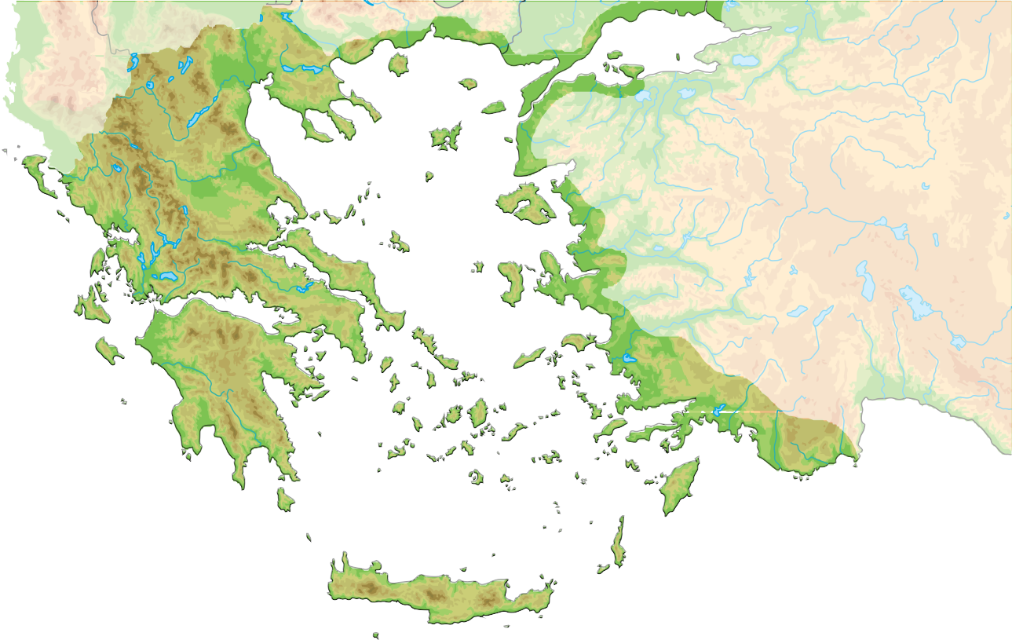
Byzantium
Illyria (Albania)
Mount Olympus
Corcyra
Corfu
Lesbos
Asia Minor (Turkey)
Aegean Sea
Delphi
Corinth
Olympia Corinth
Isthmus of
Eretria Thebes
Athens
Ephesus
Ionian Sea
Argos Mycenae
Peloponnese
Cyclades
Sparta
Dodecanese Islands
Rhodes
Key
north
ancient Greece
river
city state mountain
Knossos
west
east
Mediterranean Sea
Crete
south
Geography of ancient Greece

How geography had an impact on ancient Greek civilisation and culture

- Read a book containing Greek myths. Choose your favourite myth and retell the story to a family member. Afterwards, illustrate your favourite scene from the story. Write a description beneath your picture to explain what is happening .

- Read the children’s story, Timon of Athens: A Shakespeare Children’s Story by Macaw Books, an adaptation of Shakespeare’s famous play about a rich Athenian who loses his wealth. After reading, write a book review that includes the title, author, plot summary, characters, settings, themes, your opinion and a star rating.

- The achievements of the ancient Greeks influenced the wider world in many fields, such as medicine, education, democracy and philosophy. Find out about the achievements of a famous ancient Greek person who interests you. Some famous Greeks include Plato, Socrates, Hippocrates and Alexander the Great. Record your findings.

- Finish your home learning by writing a summary of the topic, explaining what you have learned about ancient Greece.

Useful websites
British Museum – Collection
BBC Bitesize – KS2 History – Ancient Greece DKfindout! – Ancient Greece For Kids
Britannica Kids – Ancient Greece – Homework Help BBC Bitesize – KS2 History – How to be a historian

Good reads

Title | Author | ISBN
Discover & Learn: Ancient Greeks The Study Book | CGP | 9781782949671
Ancient Greece (DK Eyewitness Workbooks) | DK | 9780241485897
Geography Matters in Ancient Greece | Melanie Waldron | 9781406291261
Great Leaders and Thinkers of Ancient Greece | Megan C Peterson | 9781474717519
Groovy Greeks – Horrible Histories | Terry Deary | 9781407163833
Greek Myths: Meet the heroes, gods, and monsters of ancient Greece | DK  Jean Menzies | 9780241397459

